**Django Frameworking (installation and sample *basic ‘poll’* site creation)–**

**Refs:**

**About**

<https://www.djangoproject.com/>

**Versioning/Support**

<https://docs.djangoproject.com/en/2.0/faq/install/#faq-python-version-support>

**Install**

[**https://docs.djangoproject.com/en/2.0/topics/install/**](https://docs.djangoproject.com/en/2.0/topics/install/)

**Docs**

<https://docs.djangoproject.com/en/2.0/>

**Tuts**

<https://docs.djangoproject.com/en/2.0/intro/tutorial01/>

**Sqlite3 windows download:**

<http://www.tutorialspoint.com/sqlite/sqlite_installation.htm>

**command line interface (cli)-**

<http://sqlite.org/cli.html>

**Nice windows terminal –** Def. a +!!

<http://www.fosshub.com/ConEmu.html>

**Nice windows editor–** Def. a +!!

<http://www.sublimetext.com/3>

Preliminary software items needed:

-pip installer (should come packaged with python system)

-Windows PowerShell (optional), or other decent shell terminal

Useful terminal commands -*useful/unique to Powershell in windows*

**control-c** (break) -to **abort** any current task & go back to a prompt

**man** or **help** -for help on a command – example: man ls

**pip freeze or pip3 freeze**–view & verify downloaded updated packages inside

virt. environment

**history** -nuff said! A history of your commands!

**cd** -change directory

**cd ..** –gets you up the directory tree

**clear or cls** -to clear your screen

**pwd** –present working directory

\*\*\*\***tree /F**  -**view directory structures in a tree format (great command!)\*\*\*\***

**Django install(s)**

1. Download Django 2.0.4 from here:

<https://www.djangoproject.com/download/>

2. Install Django 2.0.4 from here:

<https://docs.djangoproject.com/en/2.0/topics/install/>

3. (Optional) Download **sqlite3** Precompiled Binaries for windows here:

<http://www.sqlite.org/download.html>

follow instructions to load it into your machine here:

<http://www.tutorialspoint.com/sqlite/sqlite_installation.htm>

Windows OS optional config: Set path environmental variable as follows:

Navigate to **Control Panel\System and Security\System**

Click on **Advanced system settings** and set your Path environmental variable to your folder you installed sqlite to

ex. set to the end of your path **EXACTLY** as **;c:\sqlite**

***RESTART windows at this point to have your new settings kick in.

After reboot, open up a separate command prompt to test the execution of sqlite command line interface:

ex.

C:\Windows\system32>**sqlite3**

SQLite version 3.23 2018-04-06 8:17:19

Enter ".help" for usage hints.

Connected to a transient in-memory database.

Use ".open FILENAME" to reopen on a persistent database.

sqlite>

Ex. Open up a database with sqlite3 from the command prompt

-use sqlite3 followed by your **database file name/ext**:

C:\django>cd mysite

C:\django\mysite>ls

db.sqlite3 manage.py mysite

C:\django\mysite>**sqlite3 db.sqlite3**

SQLite version 3.23 2018-04-06 8:18:19

Enter ".help" for usage hints.

sqlite> .schema

[Optional] Note – if you like set up your environmental variables for python.exe, Scripts dir, etc., if you haven’t already. Ex. follows…

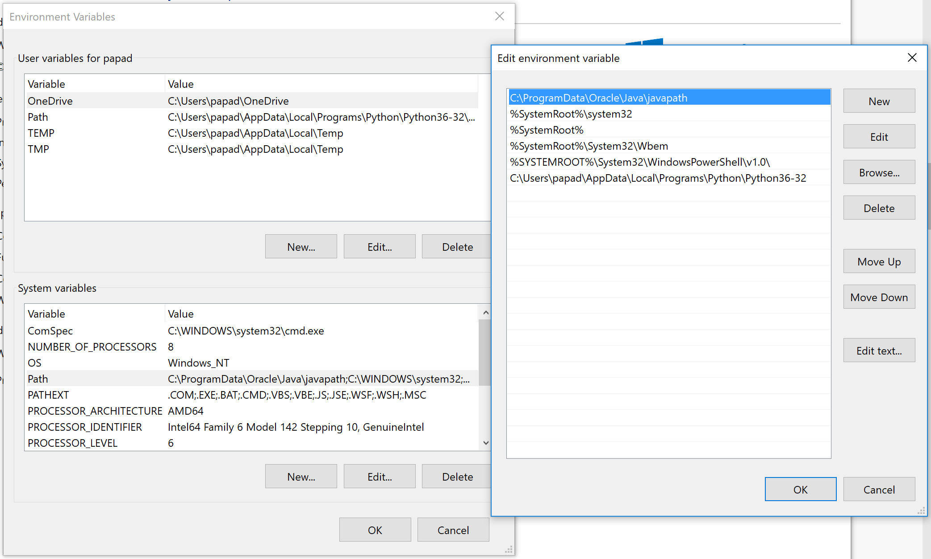

4. Now go to the site below and follow the basic instructions to create your first MVT style django app!

<https://docs.djangoproject.com/en/2.0/intro/tutorial01/>

Note well the tips / notes shaded in light green! Also read over initial part 1 instructs in depth as they will give you an overall scope of how the Django framework works!

*Try to work the first 4 tut parts! :)

Done!!! ☺

Now ready to setup a [virtual environment](https://virtualenv.pypa.io/en/stable/installation/) and install Django!

a. Go to a desired directory to create projects in…

I choose my desktop. I will call my folder projects

**mkdir projects**

**cd projects**

Now that I’m in my directory I will create a virtual environment

**virtualenv v1**

view what’s inside the ‘virtual’!!!!

**cd v1**

**dir (ls** if executing in **PowerShell/linux/Mac terminal)**

now install django if need be

**pip install django** or **pip3 install django**

b. Now from within your **v1** directory, create your project by running your **django-admin.py** command. Name your project, **myproject**.

**python C:\Python27\Scripts\django-admin.py startproject myproject**

*-of course you may be running a differing python version so adjust the above line where necessary.*

On mac/linux

django-admin startproject myproject

Cool- check out your myproject files!

**cd myproject\myproject**

**dir or ls**

c. Next setup a database (backend) to support various transactions, such as administrative, site, etc., for your project by editing the ‘**settings.py**’ file in your **myproject** subdir. We’ll call the dbase **mysite**. Open and edit the file as follows...

DATABASES = {

'default': {

'ENGINE': 'django.db.backends.sqlite3',

'NAME': os.path.join(BASE_DIR, 'mysite.sqlite3'),

}

Save and close out of your file.

Now in your prompt type – in the root of your project in your virtual environment

(…**v1/myproject** ) perform the following to sync your db! (Make sure your logged in as Administrator for this!!!)

**python manage.py migrate** or **python3 manage.py migrate**

You will see various [migrations](https://stackoverflow.com/questions/29980211/django-1-8-whats-the-difference-between-migrate-and-makemigrations) that render model states.

Example command run:

PS C:\Users\minimac\Desktop\v1\myproject> python manage.py migrate

Operations to perform:

Apply all migrations: sessions, auth, admin, contenttypes

Running migrations:

Rendering model states... DONE

Applying contenttypes.0001_initial... OK

Applying auth.0001_initial... OK

::

Applying sessions.0001_initial... OK

d. Ok now let’s create a project site.

As this is your first time using Django, you’ll have to take care of some initial setup. Namely, you’ll need to auto-generate some code that establishes a Django [project](https://docs.djangoproject.com/en/1.11/glossary/#term-project) – a collection of settings for an instance of Django, including database configuration, Django-specific options and application-specific settings.

At a desired directory / prompt type in the following to create your site project :

**django-admin startproject myproject**

This will create a **myproject** directory in your current directory.

Run

**tree /f**

to see a nice tree result of your directories!

Ex. (yours may vary)

C:\projects\v1\myproject>tree /f

Folder PATH listing

Volume serial number is 0000005C B8DA:0701

C:.

│ manage.py

│ mysite.sqlite3

│

├───myproject

│ │ settings.py

│ │ urls.py

│ │ wsgi.py

│ │ __init__.py

│ │

│ └───__pycache__

│ settings.cpython-36.pyc

│ urls.cpython-36.pyc

│ wsgi.cpython-36.pyc

│ __init__.cpython-36.pyc

│

└───mysite

│ manage.py

│

└───mysite

settings.py

urls.py

wsgi.py

__init__.py

Ex. with some python source files (forms,etc) added in for a given project (under proj. root)

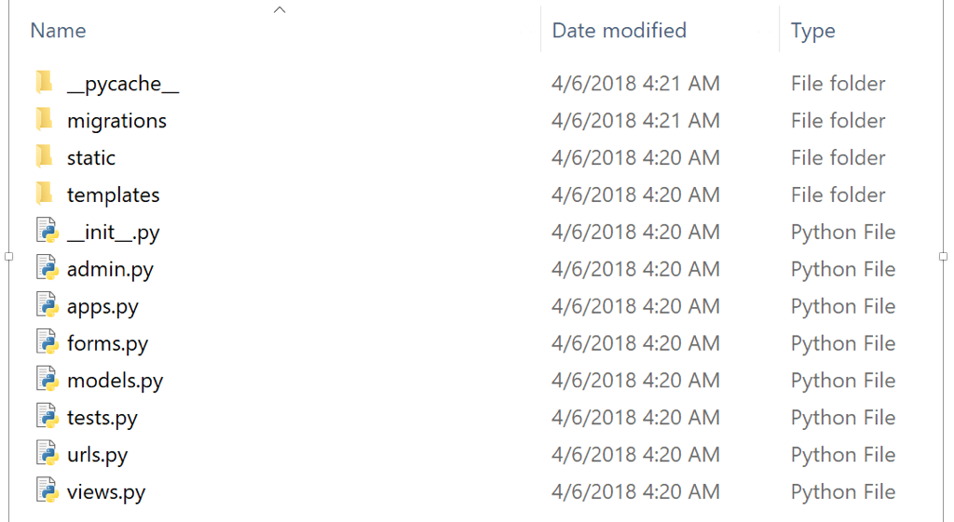

e. Great job so far. Now let’s test a page!

Type in the following to run your server and see your site in action in your browser!

Again from you myproject root folder type…

**python manage.py runserver** or **python3 manage.py runserver**

Go to your browser and type the folowing url

**127.0.0.1:8000**

You should see something similar to the following:

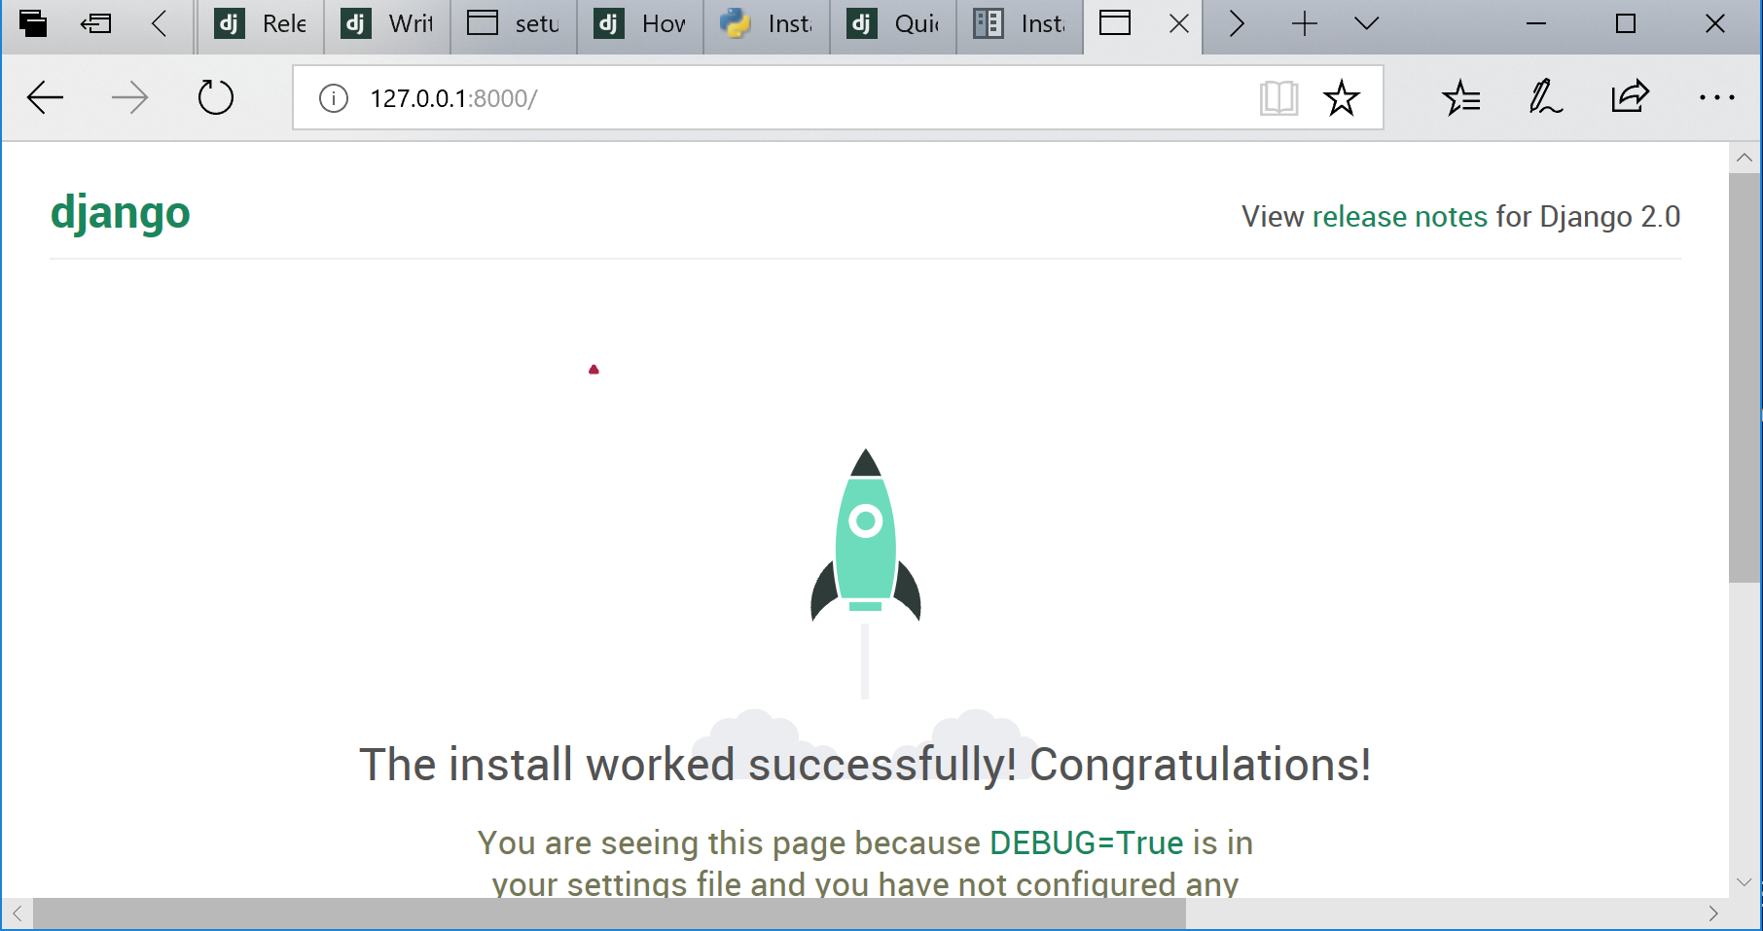

Try also typing in **127.0.0.1:8000/admin** as an ‘admin’ and attempt a log in. If you can’t see how to add in a user with admin rights, etc.

Notice your command prompt when you start your page:

Ex.

C:\Users\minimac\Desktop\v1\myproject> python manage.py runserver

yproject> python manage.py runserver

Performing system checks...

System check identified no issues (0 silenced).

July 25, 2017 - 20:47:50

Django version 1.11.3, using settings 'myproject.settings'

Starting development server at http://127.0.0.1:8000/

Quit the server with CTRL-BREAK.

Try going to **127.0.0.1:8000/admin** as an admin and attempt a log in. If you can’t see how to add in a user with admin rights, etc.

Quit the server from your prompt by typing **ctrl + c.**